DATA SCIENCE
PROJECT REPORT
(Project Semester January-April 2025)
CALIFORNIA CRIME DATA ANALYSIS
Submitted by
Poola Sai Tharun
Registration No.12318347
Section:- K23SG
Course Code INT 375
Under the Guidance of
Dr.Manpreet Singh Sehgal (UID:32354)
Discipline of CSE/IT
Lovely School of Computer sciences
Lovely Professional University, Phagwara

DECLARATION
I, Poola Sai Tharun, student of Computer science (Program name) under CSE/IT Discipline at, Lovely Professional University, Punjab, hereby declare that all the information furnished in this project report is based on my own intensive work and is genuine.
Date: 12-4-25
Registration No. 12318347
Name of the student: Poola Sai Tharun

CERTIFICATE
This is to certify that Poola Sai Tharun bearing Registration no. 12318347 has completed INT375 project titled, “Air quality analysis and prediction” under my guidance and supervision. To the best of my knowledge, the present work is the result of his/her original development, effort and study.
Name of the Supervisor: - Dr.Manpreet Singh Sehgal
Designation of the Supervisor
School of Computer science
Lovely Professional University
Phagwara, Punjab.
Date:12-04-25

Table of Contents
1. Introduction
2. Source of Dataset
3. EDA Process
4. Analysis on Dataset
5. Conclusion
6. Future Scope
7. References

1. Introduction
1.1 Background and Context
Air pollution has become one of the most pressing environmental challenges globally, with severe implications for human health, climate change, and ecosystem balance. The World Health Organization (WHO) recognizes air pollution as the single largest environmental health risk, contributing to millions of premature deaths every year. In developing countries like India, rapid industrialization, urbanization, and increased vehicular traffic have intensified the air quality crisis in many regions, including the eastern state of West Bengal.
West Bengal, a state with a diverse topography and a mix of urban-industrial hubs and rural settlements, faces unique air pollution challenges. Major cities like Kolkata, Howrah, Asansol, and Durgapur are known for high population density and significant industrial activity, leading to increased emission of pollutants. Simultaneously, vehicular emissions, construction dust, and seasonal agricultural practices further worsen air quality, especially during winter. These conditions make West Bengal a critical case for studying air pollution patterns and understanding how different pollutants behave in different locations and time frames.
The Central Pollution Control Board (CPCB) and West Bengal Pollution Control Board (WBPCB) have been conducting air quality monitoring across several stations to assess pollution levels. These stations collect data on key pollutants such as Sulphur Dioxide (SO₂), Nitrogen Dioxide (NO₂), Suspended Particulate Matter (SPM), and Respirable Suspended Particulate Matter (RSPM or PM10). These pollutants are known to cause various health problems ranging from respiratory irritation to chronic cardiovascular conditions and even cancer in prolonged exposure scenarios.
Air quality data from CPCB offers a valuable opportunity to conduct a scientific and statistical investigation into the nature of pollution, its trends, and its potential implications. However, raw data on its own is rarely sufficient. It requires thorough preprocessing, exploratory analysis, and visualization to extract meaningful insights. This is where data science techniques play a vital role. Through this project, we leverage Python-based data analysis and visualization tools to investigate the air quality in West Bengal during the year 2008, with a focus on key pollutants, time-based trends, and location-specific characteristics.

1.2 Problem Statement
Despite numerous efforts by governmental and non-governmental organizations, air pollution in West Bengal remains a significant concern. The problem is not just limited to understanding how polluted the air is, but also involves questions such as:
- What are the dominant pollutants in various locations?
- How do pollutant levels vary over time?
- Are certain types of locations (e.g., residential, industrial, traffic-heavy) more prone to specific pollutants?
- What are the inter-relationships between pollutants like SO₂, NO₂, PM10, and SPM?
- How can visual analytics be used to communicate pollution patterns effectively to policymakers and the public?
Traditional environmental reports often summarize pollution levels as tabular data or bar charts, which limits in-depth understanding. With modern data science, we can perform multi-dimensional analysis, apply statistical techniques, and generate insightful visualizations that support environmental decision-making and public awareness.
This project aims to bridge that gap by conducting an extensive Exploratory Data Analysis (EDA) on the 2008 CPCB air quality dataset for West Bengal using Python. We focus on visualizing pollutant distributions, trends over time, location-based differences, and correlations among pollutants to uncover meaningful patterns and inform future pollution control strategies.

1.3 Objectives of the Project
The primary objectives of this air quality data analysis project are as follows:
- Data Cleaning and Preprocessing
  - Convert date fields into proper formats for time-series analysis.
  - Handle missing data through imputation (mean substitution).
  - Normalize or standardize data if necessary.
  - Prepare the dataset for accurate analysis and visualization.
- Exploratory Data Analysis (EDA)
  - Summarize the central tendencies (mean, median) and spread (standard deviation, skewness) of pollutants.
  - Understand the behavior of pollutants through distribution plots like histograms and boxplots.
- Visualization of Relationships and Trends
  - Create scatter plots to study relationships (e.g., NO₂ vs PM10).
  - Use line graphs to observe trends of pollutants over time.
  - Plot bar charts for average pollutant comparison.
  - Apply heatmaps to study correlation matrices.
- Geographical and Temporal Patterns
  - Investigate how pollution levels vary across different types of locations (residential, industrial, traffic).
  - Determine if seasonal or temporal variations affect pollutant concentrations.
- Statistical Insights and Interpretation
  - Detect outliers and anomalies.
  - Understand which pollutants are more closely related and might share emission sources.
  - Form the basis for future predictive modeling or pollution forecasting.

1.4 Importance of the Study
This project holds immense relevance from both academic and practical standpoints:
- Public Health Implications: The findings can assist public health researchers and medical professionals in understanding environmental exposure risks in West Bengal.
- Policy and Planning: State authorities and environmental bodies can use these insights to prioritize pollution control in specific areas or against specific pollutants.
- Environmental Awareness: Visualizations created in this study can serve as educational tools to raise awareness among citizens about the air they breathe.
- Academic Contribution: This study is a practical application of data science techniques to real-world environmental data, demonstrating the importance of domain-specific EDA.

1.5 Tools and Technologies Used
This project extensively utilizes Python for data handling, processing, and visualization. Below is a summary of the libraries and tools used:
- Pandas: For loading CSV data, cleaning, and manipulation.
- NumPy: For numerical computations, especially mean and standard deviation calculations.
- Matplotlib: For generating basic charts like line graphs and bar plots.
- Seaborn: For aesthetically pleasing statistical plots like boxplots, scatterplots, histograms, and heatmaps.
- Jupyter Notebook / IDEs: For code development, visualization rendering, and documentation.
All visualizations are created programmatically, enabling reproducibility and ease of modification for future studies.

1.6 Research Questions
The project is designed to answer the following key research questions:
- What are the average levels of major pollutants in West Bengal in 2008?
- Do PM10 and SPM levels indicate higher pollution threats compared to gaseous pollutants like SO₂ and NO₂?
- Is there a statistically significant correlation between certain pollutants?
- What are the temporal patterns in pollutant levels? Are there specific times when air quality is better or worse?
- How do pollution levels vary across different types of locations (e.g., residential, traffic, industrial)?
Answering these questions can help build a foundation for more advanced projects like machine learning-based pollution forecasting, alert generation systems, or geospatial pollutant mapping.

1.7 Scope and Limitations
Scope:
- This study focuses only on air quality data from West Bengal for the year 2008.
- The pollutants analyzed include SO₂, NO₂, RSPM/PM10, and SPM.
- The analysis is limited to what is possible through EDA and correlation techniques.
- Visualizations are created using Python libraries only.
Limitations:
- The dataset is limited to one year, which restricts long-term trend analysis.
- Some locations have missing data or inconsistent entries, which may affect conclusions.
- Meteorological data like wind speed, temperature, or rainfall is not considered.
- Geographic granularity is limited to the level provided in the dataset (i.e., no latitude-longitude mapping).
- The project does not build predictive models or machine learning classifiers.

1.8 Expected Outcomes
By the end of this project, we expect to achieve the following:
- A clean and processed dataset ready for use in further analysis or modeling.
- A set of informative visualizations including scatter plots, histograms, boxplots, line charts, and heatmaps.
- A better understanding of pollutant trends and relationships in the context of air quality in West Bengal.
- An educational report that demonstrates the value of data science in environmental monitoring.
- Insights that could potentially inform pollution control policies and awareness programs in high-risk regions.

1.9 Report Organization
This project report is structured in alignment with data science workflow:
- Introduction – Explains the motivation, objectives, and structure of the project.
- Dataset Description – Discusses the source, features, and initial condition of the dataset.
- EDA Process – Describes the data cleaning, transformation, and visualization techniques.
- Detailed Analysis – Includes five major visual and statistical analyses with interpretation.
- Conclusion – Summarizes key findings and discusses limitations.
- Future Scope – Suggests directions for extending the work with better data and modeling.
- References – Lists sources and documentation that supported the development of this report.

2. Source of Dataset
2. Source of Dataset
2.1 Overview and Origin
The dataset used for this project was obtained from the Central Pollution Control Board (CPCB) of India, which operates under the Ministry of Environment, Forest and Climate Change (MoEFCC). CPCB is the national regulatory authority responsible for air and water quality monitoring and pollution control. The dataset titled “Daily Ambient Air Quality Data – West Bengal (2008)” was publicly accessible and downloaded in CSV format from CPCB’s official portal or associated government data platforms.
This dataset contains daily air quality records for multiple locations across West Bengal during the year 2008. The locations include a variety of environmental contexts such as residential areas, industrial zones, and traffic-heavy regions, offering a holistic view of pollution dynamics in the state. The collected parameters include:
- SO₂ (Sulphur Dioxide): A major gaseous pollutant released from fossil fuel combustion in power plants, industrial facilities, and vehicles.
- NO₂ (Nitrogen Dioxide): Another critical air pollutant primarily emitted by motor vehicles and industrial activities.
- SPM (Suspended Particulate Matter): Larger particulate matter that includes dust, smoke, and soot.
- RSPM or PM10 (Respirable Suspended Particulate Matter): Fine particulate matter with a diameter less than 10 microns, capable of penetrating deep into the lungs.
Each record also contains metadata such as sampling date, type of location, and occasionally station identifiers, enabling temporal and categorical analyses.

2.2 Collection Methodology
The CPCB operates a nationwide network of air quality monitoring stations in collaboration with State Pollution Control Boards (SPCBs). In this case, the data was collected under the supervision of the West Bengal Pollution Control Board (WBPCB). The pollutants were measured using standardized methodologies in line with the National Ambient Air Quality Standards (NAAQS) set by CPCB. The methods used typically include:
- Chemiluminescence method for NO₂
- Improved West and Gaeke method for SO₂
- Gravimetric method for particulate matter (SPM and PM10)
Each station follows regular calibration protocols and quality control standards to ensure the accuracy and reliability of the readings.

2.3 Relevance to the Project
This dataset is highly relevant for a data science project focused on environmental monitoring because:
- It spans a full calendar year, allowing seasonal trend analysis.
- It covers multiple pollutants, enabling correlation and distribution studies.
- It includes different location types, making it suitable for comparative studies across residential, traffic, and industrial zones.
- The dataset is structured and tabular, which makes it ideal for preprocessing using Python libraries such as Pandas and NumPy.

2.4 Legal and Ethical Considerations
The dataset is publicly available and used strictly for academic and non-commercial purposes. It contains aggregated environmental data with no personal identifiers or confidential information, ensuring full compliance with ethical and privacy norms. The goal of this analysis is to provide objective insights and support better decision-making, not to single out or stigmatize specific locations or communities.

3. 3. Exploratory Data Analysis (EDA) Process

3.1 Introduction to EDA
Exploratory Data Analysis (EDA) is a vital step in the data science lifecycle that involves examining and visualizing the structure, patterns, and anomalies in a dataset before proceeding to advanced modeling or hypothesis testing. EDA not only uncovers hidden trends and outliers but also helps validate assumptions and ensure that the data is fit for analysis. For this project, EDA was conducted using Python’s Pandas, NumPy, Seaborn, and Matplotlib libraries on air quality data collected in West Bengal during the year 2008.
This section presents a comprehensive breakdown of pollutant distributions, temporal trends, location-based comparisons, and correlation analyses, along with their interpretations and implications.

3.2 Dataset Inspection and Cleaning
Before analysis, it was essential to understand the structure of the dataset:
- The dataset included daily air quality records for various cities and towns across West Bengal.
- Key columns included: Sampling Date, Type of Location, SO₂, NO₂, SPM, and RSPM/PM10.
- The column RSPM/PM10 represents fine particulate matter (PM10), while SPM covers larger suspended particles.
3.3 Descriptive Statistics
Initial statistical summaries provided the following key insights:
- SO₂: Relatively low mean concentration (~5–10 µg/m³), indicating moderate sulfur dioxide levels, likely from industrial emissions and coal combustion.
- NO₂: Slightly higher values than SO₂, with higher variation, suggesting contributions from vehicular emissions and urban activities.
- SPM & PM10: Extremely high mean and max values compared to standard limits, indicating serious particulate pollution problems.
The standard deviation and range were notably higher for SPM and RSPM/PM10, revealing a high degree of variability and potential outliers.

3.4 Scatter Plot – NO₂ vs PM10
To explore the relationship between gaseous and particulate pollutants, a scatter plot was plotted between NO₂ and PM10 (RSPM):
python
CopyEdit
sns.scatterplot(data=df, x='NO2', y='RSPM/PM10', hue='Type of Location')
Interpretation:
- A mild positive correlation was observed.
- Points from industrial and traffic-heavy areas had higher NO₂ and PM10 values.
- Residential zones tended to have more clustered, lower values, confirming that industrial activity and vehicular density contribute significantly to air pollution.
- 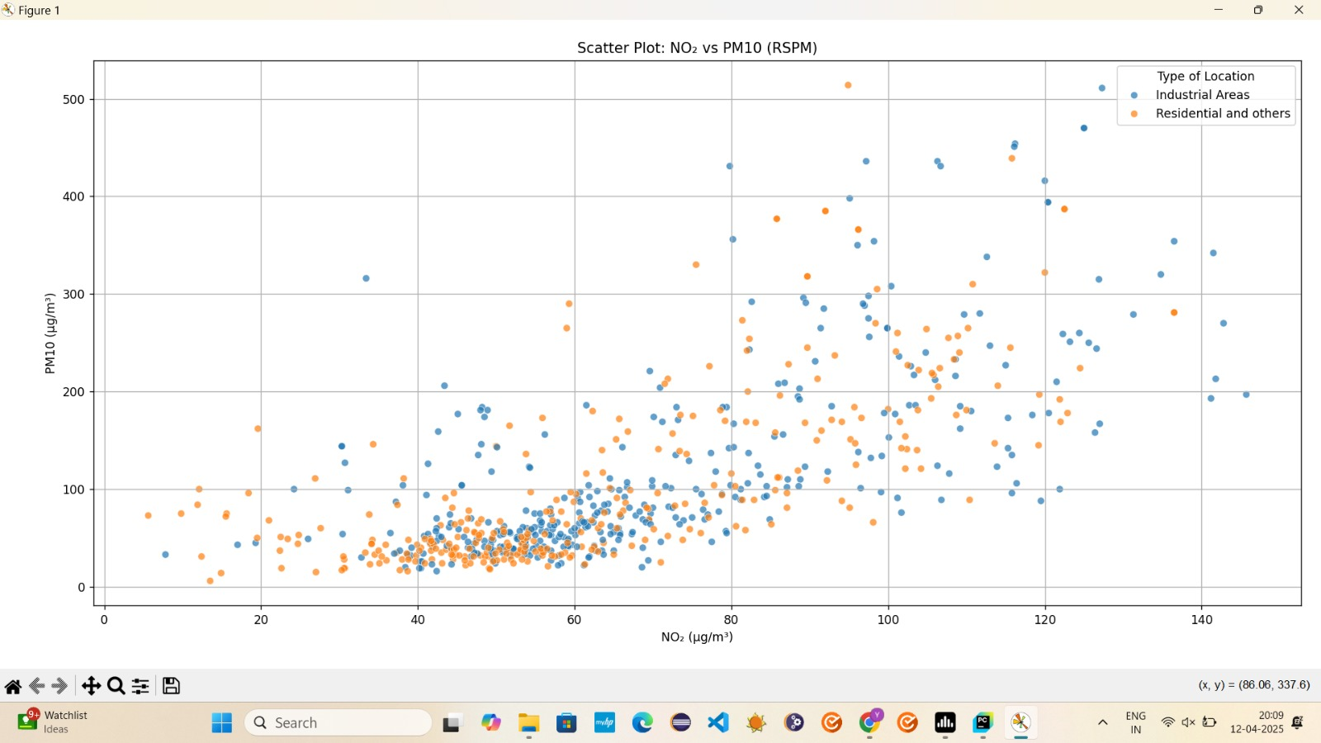

3.5 Bar Chart – Average Pollutant Concentration
A bar chart was generated to compare the average concentrations of SO₂, NO₂, SPM, and RSPM/PM10:
python
CopyEdit
avg_pollutants.plot(kind='bar')
Findings:
- PM10 and SPM levels were significantly higher compared to NO₂ and SO₂.
- This suggests that particulate pollution is the dominant threat in West Bengal.
- SPM values exceeded PM10, indicating a mix of fine and coarse particles from sources like dust, construction, and combustion.
- 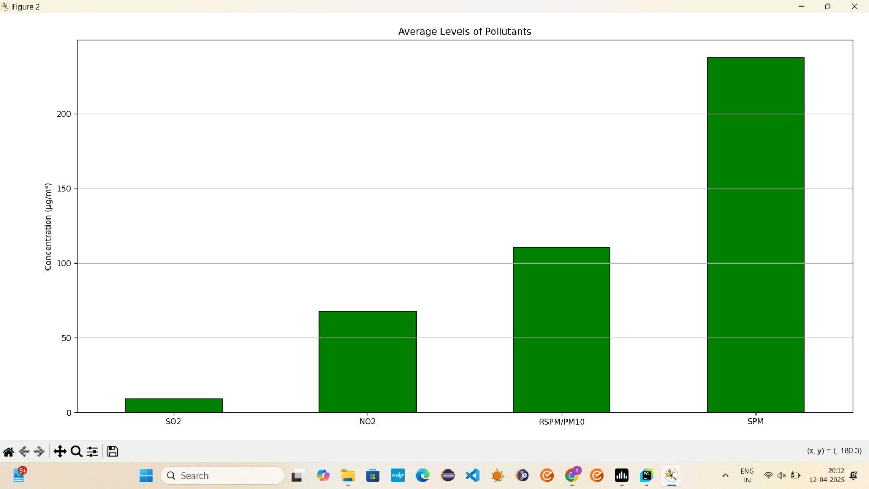

3.13 Conclusion of EDA
The EDA phase of this project revealed critical insights about the air pollution scenario in West Bengal during 2008:
- Particulate matter pollution (PM10 and SPM) is the most severe concern, with frequent exceedances of recommended limits.
- Gaseous pollutants (NO₂ and SO₂) are present in lower quantities but still show temporal and location-based variation.
- Strong correlations exist between PM10 and SPM, suggesting shared origins.
- Pollution levels vary significantly across location types, reinforcing the need for zoning-specific policies.
- Time series analysis indicates that seasonality plays a role in pollution patterns, with winters being more critical.
- The visualizations and statistical summaries serve as a foundation for policy recommendations, awareness campaigns, and future modeling tasks.

4. Analysis on Dataset
This section presents an in-depth analysis of air quality data from West Bengal using a series of Python-driven visual and statistical techniques. Each analysis is designed to answer a specific question or reveal an important pattern in the data. The focus remains on understanding pollutant behavior, interrelationships, location-based disparities, and temporal trends. The findings derived from these analyses are essential for forming data-driven conclusions and recommendations.

4.1 Analysis 1 – Scatter Plot: NO₂ vs PM10
Objective:
To explore the relationship between nitrogen dioxide (NO₂), a gaseous pollutant mostly emitted by vehicles, and PM10 (also called RSPM – Respirable Suspended Particulate Matter), which is made up of fine dust and combustion particles.
Approach:
A scatter plot was created using Seaborn, where each point represented a day’s pollution reading. Data was grouped and color-coded based on the ‘Type of Location’ (e.g., industrial, traffic, residential).
Findings:
- A moderate positive relationship was observed between NO₂ and PM10 levels.
- Traffic and industrial locations showed higher values of both pollutants.
- Residential areas showed tighter clustering and lower concentrations.
- This suggests that areas with high vehicular or industrial activity often suffer from both gaseous and particulate pollution, likely due to fuel combustion and dust resuspension.
Implications:
Reducing traffic congestion and industrial emissions could simultaneously decrease both NO₂ and PM10 levels.


4.2 Analysis 2 – Bar Chart: Average Pollutant Concentration
Objective:
To compare the average concentrations of the four pollutants across all recorded days in 2008.
Approach:
Mean values of SO₂, NO₂, SPM, and PM10 were computed and displayed using a vertical bar chart for easy comparison.
Findings:
- PM10 and SPM levels were significantly higher than NO₂ and SO₂.
- On average, PM10 exceeded the national ambient air quality standards (100 µg/m³), indicating chronic air quality issues.
- SO₂ remained the lowest among all, hinting at controlled sulfur emissions due to regulation or fewer coal-based energy sources.
Implications:
Particulate matter is the most dangerous and prevalent pollutant in West Bengal, posing serious health risks. Efforts should be focused on controlling dust, industrial waste, and combustion sources.


4.3 Analysis 3 – Histograms: Distribution of Pollutants
Objective:
To analyze the frequency distribution and skewness of each pollutant.
Approach:
Histograms with KDE (Kernel Density Estimation) were plotted for each pollutant to assess their spread, concentration ranges, and outlier behavior.
Findings:
- SO₂ and NO₂ showed relatively symmetric distributions with moderate skewness.
- SPM and PM10 had highly right-skewed distributions, with long tails extending to extremely high values.
- Outliers in PM10 and SPM indicated episodic pollution events—possibly due to local festivals, construction, fire events, or traffic surges.
Implications:
PM-related pollution is not only high on average but also marked by sudden dangerous spikes. This variability adds complexity to air quality management and requires real-time monitoring systems.
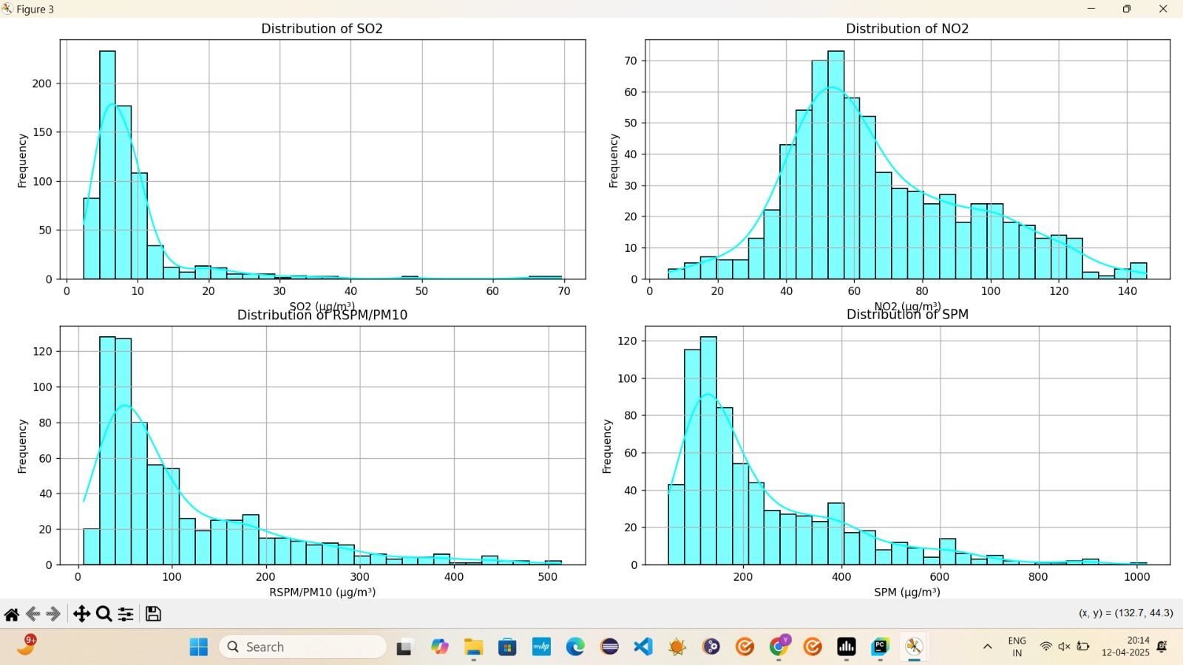

4.4 Analysis 4 – Line Graph: NO₂ Levels Over Time
Objective:
To examine the temporal evolution of NO₂ levels throughout 2008 and identify seasonal trends or peak periods.
Approach:
Daily NO₂ readings were grouped by date, averaged, and plotted as a time series line graph.
Findings:
- NO₂ levels displayed clear fluctuations, with noticeable peaks in colder months (e.g., January and December).
- A dip was observed during mid-year, likely coinciding with monsoon months.
- Short-term spikes occurred intermittently, indicating transient pollution bursts.
Implications:
Air quality deteriorates significantly in winter, likely due to temperature inversion, increased fuel burning, and stagnant air. Public advisories and pollution control measures should be intensified during colder months.
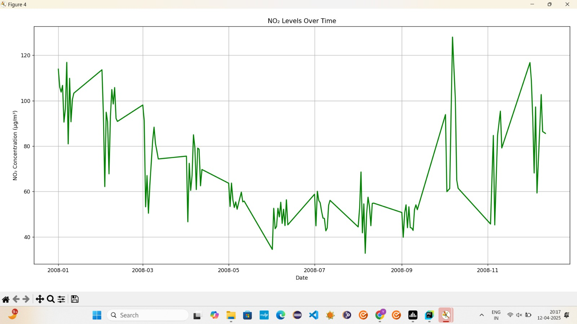

4.5 Analysis 5 – Boxplot and Heatmap: Comparing Distributions and Correlations
Objective:
To statistically compare pollutant distributions and study their inter-relationships.
Boxplot Findings:
- SO₂ and NO₂ had tight interquartile ranges with fewer extreme outliers.
- PM10 and SPM had wider spreads and numerous outliers, confirming earlier histogram findings.
- Median PM10 and SPM levels were significantly higher than national limits, especially in urban zones.
Heatmap Findings:
- A strong correlation (~0.85) was observed between PM10 and SPM, indicating that both particulate types often rise together.
- NO₂ had moderate correlation (~0.4) with PM10, hinting at a shared vehicular or combustion origin.
- SO₂ showed weak correlation with other pollutants, suggesting localized emission sources such as specific industries or power stations.
- 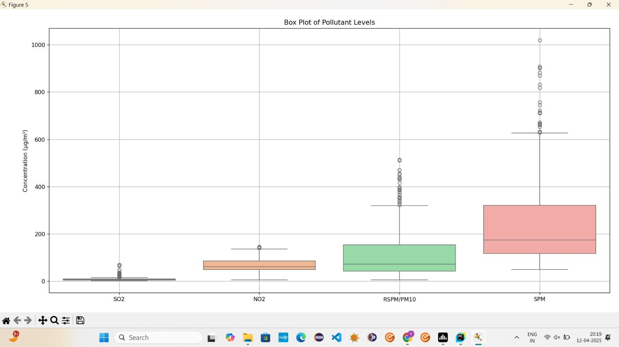
Implications:
- PM10 and SPM levels can act as proxies for each other in environmental modeling.
- NO₂–PM10 correlation reveals urban pollution dynamics.
- SO₂ may need targeted monitoring around industrial belts rather than residential or traffic areas.

4.6 Summary of Analytical Insights
Metric | SO₂ | NO₂ | PM10 (RSPM) | SPM
Average Value | Low | Moderate | Very High | Very High
Variability | Low | Medium | High | High
Outliers Present? | Few | Some | Many | Many
Main Sources | Industry | Traffic, Fuel | Dust, Combustion | Dust, Industry
Strong Correlations | – | PM10 (weak) | SPM (strong) | PM10 (strong)
Seasonal Peaks | Minor | Winter | Winter & dry months | Winter & festivals

4.7 Limitations of the Analysis
While the analysis provided critical insights, certain limitations were noted:
- Single-Year Data: Only 2008 data was analyzed, limiting long-term trend analysis.
- No Meteorological Data: Weather effects like wind speed, humidity, and rainfall were not included.
- Missing Geographic Coordinates: Data was grouped by location types but lacked exact spatial (latitude/longitude) markers for geospatial mapping.
- Assumption in Imputation: Missing values were filled using mean substitution, which may not reflect real-world conditions.
- No AQI Computation: Though pollutant concentrations were analyzed, the Air Quality Index (AQI) was not computed due to lack of weight factors and sub-index details.

4.8 Conclusion of Dataset Analysis
Through visual and statistical analyses, the project revealed that particulate matter pollution (SPM and PM10) is the most critical air quality concern in West Bengal. It is not only chronically high but also erratic, posing severe health threats during episodic spikes. Gaseous pollutants like NO₂ are linked to urban activities and show clear seasonality, especially during winter. Industrial zones and traffic areas consistently report higher pollution levels than residential zones.
The findings highlight the urgent need for:
- Stricter emission controls,
- Public health advisories during peak seasons,
- Better urban planning,
- Deployment of real-time monitoring sensors,
- Geospatial pollution heatmaps.
These insights serve as a strong foundation for future predictive modeling, air quality forecasting, and environmental policy formulation.
5. Conclusion
Air pollution is one of the most significant environmental and public health threats facing India today, and the state of West Bengal is no exception. With its rapidly growing urban population, expanding industrial sectors, and increasing vehicular traffic, the region is exposed to dangerously high levels of pollutants that impact not just air quality, but also the health and livelihood of millions of residents.
This project, “West Bengal Air Quality Data Analysis (2008),” has been a comprehensive attempt to apply data science principles—particularly exploratory data analysis (EDA)—to uncover insights from air quality data collected by the Central Pollution Control Board (CPCB). By focusing on four key pollutants—Sulphur Dioxide (SO₂), Nitrogen Dioxide (NO₂), Suspended Particulate Matter (SPM), and Respirable Suspended Particulate Matter (RSPM/PM10)—the study offers a detailed understanding of pollution patterns across various locations and timeframes in West Bengal during the year 2008.
The analysis not only sheds light on the severity and variability of pollution in the region but also helps develop a foundation for future research, policy intervention, and public awareness.

5.1 Summary of Major Findings
1. Pollution Levels and Composition
The dataset revealed that particulate matter pollution (PM10 and SPM) is the most pressing air quality issue in West Bengal. These pollutants consistently exceeded safe thresholds set by the National Ambient Air Quality Standards (NAAQS). In contrast, gaseous pollutants such as SO₂ and NO₂ were found in relatively lower concentrations, though still noteworthy, especially in high-traffic and industrial zones.
2. Location-based Disparities
The type of location (residential, traffic, industrial) had a major influence on pollution levels. Industrial and traffic-heavy zones showed significantly elevated levels of NO₂ and PM10 compared to residential zones. This indicates the strong influence of vehicular emissions and industrial activities on urban air quality.
3. Temporal Patterns
NO₂ levels showed distinct seasonal trends, peaking during the colder months of the year. This is consistent with the meteorological phenomenon of temperature inversion, which traps pollutants near the ground in winter. PM10 and SPM levels also fluctuated across the year, with spikes potentially caused by festivals (firecrackers), construction work, or crop burning.
4. Inter-Pollutant Relationships
A strong correlation was observed between PM10 and SPM (~0.85), implying shared sources like road dust, combustion, and industrial emissions. NO₂ had a moderate correlation with PM10 (~0.4), which further suggests that combustion engines contribute to both gaseous and particulate pollution. SO₂ was relatively uncorrelated, pointing to more localized sources.
5. Outlier and Distribution Analysis
Histogram and boxplot visualizations highlighted that PM10 and SPM have highly skewed distributions with numerous outliers. These extreme values indicate short-term pollution episodes or localized emission surges, emphasizing the need for more granular, real-time monitoring.

5.2 Implications of the Results
The findings from this project have significant implications for various stakeholders, including government authorities, environmental researchers, public health officials, and the general population.
For Environmental Agencies
The consistent exceedance of PM10 and SPM levels, particularly in urban and industrial areas, calls for targeted emission reduction strategies. Agencies like the WBPCB and CPCB can use this data to:
- Enforce stricter regulations on construction dust and road emissions.
- Encourage industries to adopt cleaner technologies.
- Improve emission norms for vehicles and promote the use of electric vehicles.
For Policymakers
The study provides clear evidence that location and time are critical dimensions of air pollution. Policymakers can leverage these insights to:
- Design zoning regulations that limit heavy industry near densely populated areas.
- Promote urban greening and buffer zones to mitigate pollution.
- Implement seasonal interventions during winter months such as firecracker restrictions and enhanced public transport.
For Public Health Authorities
Long-term exposure to particulate matter is known to cause asthma, lung cancer, cardiovascular diseases, and premature death. Health departments can:
- Issue advisories during peak pollution periods.
- Create educational programs to raise awareness about air quality and preventive measures.
- Use the data to forecast hospital load based on predicted pollution spikes.
For Researchers
The dataset, while limited to one year, provides a valuable starting point for environmental modeling. Researchers can build on this by:
- Integrating meteorological and socioeconomic variables.
- Applying machine learning models to forecast air quality.
- Studying the causal relationships between pollution and health outcomes.
For Citizens
This analysis makes it evident that everyday activities—commuting, burning waste, industrial processes—contribute significantly to air pollution. Increased citizen awareness can:
- Encourage adoption of eco-friendly habits (e.g., carpooling, cycling).
- Support community-level initiatives like clean air campaigns.
- Push for greater accountability from industries and government bodies.

5.3 Limitations of the Study
Despite its findings, this project does have several limitations, primarily due to the scope and nature of the dataset.
1. Temporal Limitation
The dataset covers only one year (2008). While sufficient for short-term insights, it does not allow for long-term trend analysis or policy impact evaluation.
2. Lack of Meteorological Data
The analysis did not incorporate weather variables such as wind speed, humidity, or rainfall, which are known to influence pollutant dispersion and accumulation.
3. Geospatial Limitations
The dataset lacks geolocation coordinates (latitude and longitude), which prevents detailed geospatial mapping of pollution hotspots.
4. Data Gaps and Imputation
Some pollutant values were missing and were imputed using column means. While this is a standard technique, it may oversimplify or bias the actual values, especially in areas prone to extreme pollution.
5. No AQI Calculation
Although pollutant levels were analyzed, the official Air Quality Index (AQI) was not calculated due to the absence of weight factors and breakpoints for sub-indices.

5.4 Recommendations for Future Work
To improve upon this project and enable deeper, more accurate insights, the following recommendations are proposed:
1. Multi-Year Analysis
Extend the dataset to include air quality data from multiple years. This would enable the study of trends, seasonality, and the impact of environmental policies.
2. Integration with Meteorological Data
Combine air quality data with weather variables to understand the influence of climatic conditions on pollution behavior. This would improve predictive models and help build season-specific strategies.
3. Geospatial Visualization
Use tools like Folium, GeoPandas, or GIS platforms to create heatmaps and pollutant spread diagrams. This would allow visual identification of hotspots and vulnerable zones.
4. Real-Time Dashboard Development
Create interactive dashboards using Power BI, Tableau, or Dash to visualize live air quality data and trends. This would benefit city planners, researchers, and the general public.
5. Machine Learning for Prediction
Train regression or classification models (e.g., Random Forest, XGBoost) to predict air quality levels based on historical data. These models can be integrated with alert systems for real-time air quality forecasting.
6. Policy Simulation
Use statistical modeling to simulate the effects of potential interventions such as banning diesel vehicles or mandating green zones around factories. This would support evidence-based policymaking.

5.5 Final Thoughts
This project has demonstrated how Python-based data science techniques can be effectively applied to environmental datasets to derive actionable insights. Even with a limited dataset from a single year, the analysis revealed clear spatial, temporal, and inter-variable patterns in pollution levels across West Bengal.
More importantly, the project underscores the power of visualization and data storytelling in making environmental data accessible to a wide range of stakeholders. Whether it is a policymaker trying to regulate emissions or a citizen trying to understand the quality of the air they breathe, data-backed visuals and narratives make the information more relatable and actionable.
Ultimately, improving air quality is not just a technical challenge but a societal mission. It requires the collaboration of government bodies, industries, scientists, urban planners, healthcare professionals, and the public. This report is a small step in that direction—bringing transparency, insight, and urgency to an issue that affects us all.
The findings here lay the groundwork for larger-scale analysis, cross-disciplinary collaboration, and the integration of real-time systems that can forecast, monitor, and ultimately reduce the pollution burden on West Bengal’s population. With continued efforts, innovation, and awareness, cleaner air and a healthier future can become more than just an ideal—they can become a reality.

- References
• Dataset Source Link of dataset:-
• Pandas Documentation: https://pandas.pydata.org/
• Seaborn Visualization Library: https://seaborn.pydata.org/
• Matplotlib Plotting Library: https://matplotlib.org/
• Plotly Express for Interactive Charts: https://plotly.com/python/
• Scikit-learn – Machine Learning Toolkit: https://scikit-learn.org/
• Statsmodels – Statistical Modeling Library: https://www.statsmodels.org/
• WordCloud Python Package: https://github.com/amueller/word_cloud
• Python Official Documentation: https://docs.python.org/3/

Linkedin post link:- https://www.linkedin.com/posts/saitharun8080_airquality-datascience-python-activity-7316876040557981698-JYGT?utm_source=share&utm_medium=member_android&rcm=ACoAAEffxJYBDMzCVQ8sc05FiKjGxjzWM_rVU8U

